On the road to a
better CTP scheme
Options for reforming Green Slip
insurance in NSW

Contents
Minister’s foreword 3
The NSW Motor Accidents Compulsory Third Party (CTP) Scheme 4
What should an effective CTP scheme deliver? 5
How is the current CTP scheme performing against these objectives? 6
Proportion of benefits 6
Timeliness of payments 7
Scheme integrity 8
Affordability 9
Some policy issues 12
Fault versus no-fault 12
Coverage for other injured road users 12
First party versus third party scheme 12
Profit and competition 13
Underwriting considerations 13
Wrong doing 14
Adequacy and consistency of lump sum payments 14
Abuse of the system 15
Potential reform options 16
Option 1 – Retain the current common law, fault-based scheme with process improvements 17
Option 2 – Retain the current common law, fault-based scheme with adjustments to benefit levels as well as process improvements 18
Option 3 – Move to a hybrid no-fault, defined benefits scheme with common law benefits retained in parallel 19
Option 4 – Move to a fully no-fault, defined benefits scheme with caps, thresholds and no common law 21
How to make a submission 23
Glossary 24
Appendix: Comparison of schemes around Australia 25

Minister’s foreword
Each year, the NSW Compulsory Third Party (CTP) insurance scheme provides support to around 16,000 people injured on the state’s roads. Also known as the Green Slip scheme, it provides a range of benefits to injured road users including medical expenses, compensation for economic loss and payments for pain and suffering for those with permanent injuries.
The current scheme has been in place for more than 15 years and the NSW Government is committed to ensuring that it works well and is sustainable into the future.
The Government last reviewed the CTP scheme in 2013 and while a final set of reforms was not agreed, there was broad consensus that the current scheme needs to be improved.
It has become increasingly clear in recent years, and particularly over the last 12 months, that the system is not serving injured road users as well as it could. Only 45 cents in every Green Slip dollar ends up in the hands of injured road users – the rest is absorbed by scheme costs and provider fees.
Another key concern relates to the claims process. A person injured in a motor vehicle accident can wait between three and five years for their claim to be resolved. At the same time, Green Slip premiums have increased significantly and are now one of the most expensive in Australia. We know that, without scheme reform, there’s likely to be further premium increases in the coming years.
The CTP scheme is also being challenged by a significant increase in fraudulent and exaggerated claims, the costs of which are ultimately reflected in increased Green Slip prices.
For these reasons the Government believes the time is right for a major scheme review.
This Options Paper represents the first step in a genuine and broad-ranging consultation process aimed at creating a fairer and more affordable scheme for road users. It focuses on four key objectives:
- increasing the proportion of benefits provided to the most seriously injured road users
- reducing the time it takes to resolve a claim
- reducing opportunities for claims fraud and exaggeration
- reducing the cost of Green Slip premiums.
We recognise that there are no right or wrong answers, rather different options for scheme design.
Different Australian states take different approaches – NSW, Queensland, Western Australia and the ACT have primarily fault-based schemes, whereas Victoria, Tasmania and Northern Territory have no-fault or hybrid systems.
This paper puts forward a number of options, including retaining and improving the current common law fault-based system, as well as moving to a no-fault, defined benefits system. A hybrid option is also outlined along with possible premium and underwriting system reforms.
All road users have an important stake in our CTP insurance system and I encourage you to make your views known by lodging a submission. We greatly value your input.
Following consultation, the Government will report back with preferred reform options in the second half of the year.
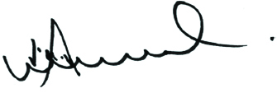

The Hon Victor Dominello MP
Minister for Innovation and Better Regulation

The NSW Motor Accidents Compulsory Third Party (CTP) Scheme
Despite our best road safety efforts, around 25,000 people are injured in motor vehicle accidents in NSW each year. People injured in motor vehicle accidents often require support to cover medical and rehabilitation costs, suffer financial losses as a result of time off work, and in some cases, face a reduction in future earning capacity.
CTP Green Slip insurance is a mandatory insurance product intended to ensure that people injured in motor vehicle accidents receive the support they need as a result of injuries incurred. Without CTP insurance, vehicle owners would have to personally pay for any injuries they may cause to another person, which many motorists would not be able to afford. If those responsible are unable to pay then the injured person would be left to carry the cost of their injury themselves.
CTP insurance is required in order to register a vehicle in NSW and protects the owner from being personally sued for any injuries their vehicle causes to passengers, the drivers and passengers of other vehicles, pedestrians and cyclists.
Since 1988 the NSW CTP scheme has been provided by private insurance companies which are licensed and overseen by the State Insurance Regulatory Authority (SIRA). At present, the vehicle owner must buy their insurance from one of six licensed insurers.
Green Slip prices are set independently by these insurers having regard to the likely costs of claims and the associated costs of delivery. They determine different pricing strategies, depending on their particular business strategy. Although SIRA does not set or approve prices, it plays a role in premium pricing by determining the extent of cross subsidies (that is, the practice of charging higher prices to one group of consumers in order to subsidise lower prices for another group). This ensures that customers considered to be a higher risk, such as young drivers, are not priced out of the CTP market.
While all Australian states and territories, and most jurisdictions abroad, have CTP schemes, they differ vastly in their operation and the level of coverage and benefits provided. In some places, like Victoria, Tasmania, Northern Territory and New Zealand, all road users are covered if they are injured in a motor vehicle accident, regardless of who was at fault in the accident. In other places, such as New South Wales, Queensland, South Australia, Western Australia and the ACT, an injured person is only able to make a CTP claim if they can show that the motor vehicle accident was caused through the fault of another driver.
If you are injured in a motor vehicle accident in NSW, and you can establish the fault of a driver, the insurance company will pay benefits, which need to be negotiated and will sometimes be reduced to the extent that the injured person contributed to their own injuries.

The NSW Motor Accidents Compulsory Third Party (CTP) Scheme
Benefits under the CTP scheme include past and future medical, treatment and rehabilitation expenses, domestic assistance, past and future economic loss and for those who exceed a prescribed impairment threshold, damages for non-economic loss or ‘pain and suffering’. These are paid primarily as a lump sum, although some expenses are paid along the way including medical, rehabilitation and treatment services and domestic assistance. There are some limits placed on benefits in the legislation. Once the lump sum has been paid, no further claim can be made on the insurer.
The NSW CTP scheme also incorporates a Nominal Defendant scheme, which ensures that people injured in an accident where the vehicle at fault was uninsured or unidentified are still entitled to the same benefits as those covered by a valid Green Slip.
CTP in NSW provides benefits of up to $5,000 irrespective of fault, through an early claim system called the Accident Notification Form (ANF).
An exception to fault applies for ‘blameless accidents’, in which an injured person can make a full claim even if the driver that caused the accident is not technically ‘at fault’, and also for children under 16, who are entitled to claim treatment, rehabilitation and care costs, regardless of fault. CTP does not cover people who are injured by non-motorised or non-registrable vehicles, including bicycles.
In addition, everyone injured in a motor vehicle accident in NSW can access public hospital and ambulance services free of charge because SIRA pays for these services in bulk, funded from a levy on each Green Slip.
Those who are severely injured in a motor vehicle accident are covered under the Lifetime Care and Support (LTCS) scheme. The LTCS scheme provides lifetime medical, care and support services to people who have been catastrophically injured in a motor vehicle accident in NSW, regardless of who was at fault. The LTCS scheme is outside the scope of this review.
Under the CTP system, some claims can get resolved by either of SIRA’s dispute resolution services: the Medical Assessment Service (for disputes related to medical matters) or the Claims Assessment and Resolution Service (for claims disputes). Some claims will also be resolved through the courts.

What should an effective
CTP scheme deliver?
The overall view emerging from the 2013 Green Slip Roundtable was that the scheme needed significant improvement. Since then, continuing community concern about difficulties in navigating the current claims process, the timeliness of benefits, rising Green Slip prices and other matters have reinforced the need to take another look at the CTP scheme.
It is necessary to consider the guiding objectives for an effective CTP scheme. In this way, we can both measure the performance of the existing scheme and begin to develop reform options that are tailored to meeting the objectives.

Based on the feedback the Government received through the 2013 Roundtable and other forums, the Government believes that any changes to the CTP scheme should achieve the following objectives:
- increase the proportion of benefits provided to the most seriously injured road users
- reduce the time it takes to resolve a claim
- reduce opportunities for claims fraud and exaggeration
- reduce the cost of Green Slip premiums.

How is the current CTP scheme performing against these objectives?
Outlined below is some information on how the current scheme is performing against each of the key objectives. This information suggests that we can do better in meeting those objectives, and this paper sets out some possible reform options for consideration to improve the scheme’s performance.

Proportion of benefits
As Figure 1 illustrates (based on historical trends), injured people are receiving 45% of CTP scheme premiums. This does not include GST or the Lifetime Care and Support levy. The remainder of funds go towards insurer expenses (15%), insurer profit (19%), legal and investigation expenses (18%), and other expenses involved in administering the scheme (3%).
The relatively low proportion of scheme funds that go towards helping injured people is largely a result of scheme design. The NSW CTP scheme operates on a common law fault-based basis. The need to establish fault, including the extent to which various parties may have caused an accident, often requires a detailed investigation.
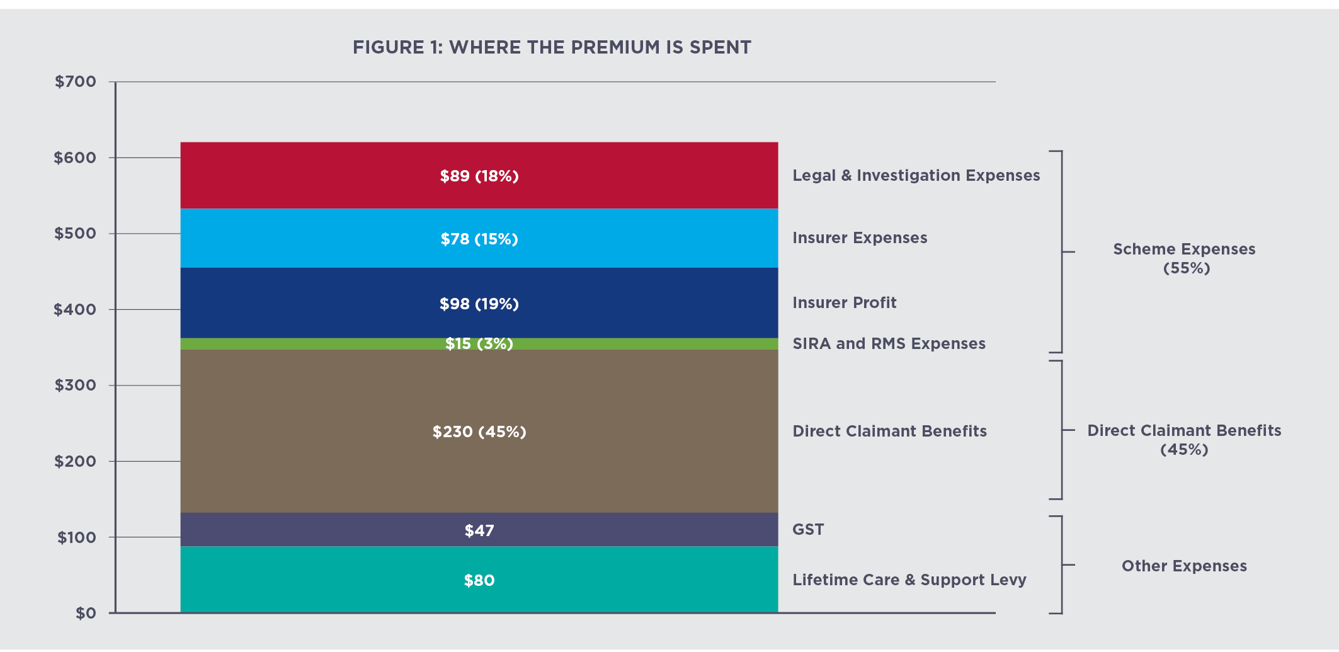

Those claiming benefits, the insurer and other parties will usually require the assistance of legal professionals in contesting the claimant’s entitlements and negotiating all aspects of the claim. This sometimes also requires the involvement of SIRA’s assessment services and/or the courts before settlement can be reached. While the assessment and dispute resolution services are designed to enable injured people to seek the maximum benefits according to their stated needs, it is often an expensive and time consuming process.
In addition to incurring significant costs, this process can generate uncertainty for insurers as payments for comparative like-for-like injuries are often different and made many years after the premium is calculated and collected. As a result, insurers factor in the risk of uncertainty when setting premiums which is leading to higher prices in the short term and higher levels of profits when claims are finally settled. This has led to the present situation where 19% of a CTP premium is on average a profit for the insurance company.

How is the current CTP scheme performing against these objectives?

Timeliness of payments
Compared to similar schemes, our CTP scheme takes a longer time to pay out benefits to claimants. In NSW, the majority of payments are made between three and five years after the accident. This is much longer than statutory benefit schemes where payments start almost immediately after a claim is made.
While incurred expenses for medical, rehabilitation and treatment services and domestic assistance are generally paid as incurred, payment of significant expenses including lost income, future treatment, rehabilitation and care are paid in a lump sum at the finalisation of the claim.
In Victoria, which has a no-fault CTP scheme, significantly more is paid to injured people within the first two years after injury. Figure 2 illustrates the lag of the NSW CTP scheme compared to the NSW workers compensation and the Victorian CTP schemes.
As highlighted in Figure 2, common law fault-based schemes, such as the NSW CTP scheme, have in-built delays in payments because of the need to establish fault, negotiate entitlement and agree on a settlement amount.
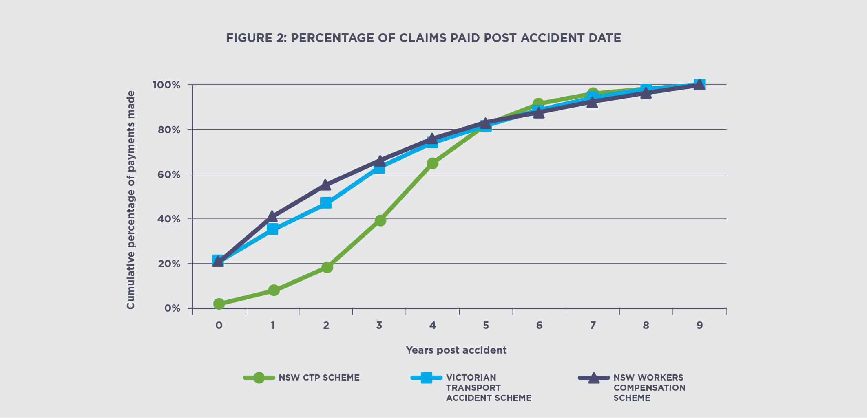
Delays to payments can mean that the injured person does not get support when they most need it. There is strong evidence that the length of time to resolve claims has a detrimental impact on injured people, who will not be encouraged to return to work and other activities because this may reduce their final claim. There is also further evidence, backed up by surveys of injured people conducted by SIRA, that injured people overall have a poor experience of the scheme, primarily because of the processes that must be undertaken before lump sum settlement is determined.
However, the trade-off for timeliness is the sense that all aspects of the claim are examined and that the injured person is able to seek the maximum benefit they need or can obtain, even though they may not have access to benefits at the point in time they incur their expenses. In NSW, with many insurance claims taking several years to resolve, it is not clear that the length of the claims process can be justified, even within the context of an at-fault, common law system.

How is the current CTP scheme performing against these objectives?

Scheme integrity
Compensation systems can be prone to fraudulent behaviour, exaggeration or embellishment of claims in order to maximise payments. Embellishment or exaggeration of a claim may be on the part of the claimant, or a willingness of service providers to assist in building the case. Lump sum systems typically can create a greater incentive for fraudulent behaviour, though weekly benefit systems also suffer from people who seek to remain on benefits for longer than they should.
The Insurance Fraud Bureau of Australia estimates up to 10% of all insurance claims could include some level of fraud. Additional costs arising from such fraud are passed on to vehicle owners in the form of increased Green Slip prices. As the table below shows, the NSW CTP scheme has among the lowest penalties for fraud of any CTP scheme in Australia.
Some recent examples of fraud and claims exaggeration that have been seen in the scheme include:
- claims for future lost income and significant future expenses for young children involved in low speed collisions
- injured people with minor injuries who after treatment were keen to return to work but were advised that they would probably get a smaller settlement if they did

 | NSW | QLD | ACT | VIC | SA
Maximum  penalty | $5,500 and/or  12 months imprisonment | $44,000 or  18 months imprisonment | $15,000 and/or  12 months imprisonment | $15,167 or  24 months imprisonment | $50,000 or  12 months imprisonment
- claims for young children, some under 12 months of age, from minor accidents seeking compensation for psychological injuries evidenced by crying and bed wetting
- low speed collisions where the extent of injuries claimed far exceeded what would be expected considering the damage to the vehicle
- people claiming to be passengers in vehicles involved in motor vehicle accidents, with further investigation to show they were not in the vehicle at the time
- claims for future lost income for high paying jobs, where investigation by the insurer has shown irregular work histories or no offer of a new job
- staged accidents involving multiple vehicles
- numerous claims from the same area with identical injuries and claim details
- claims for injuries not caused by the accident or exaggeration of injuries that were.
We must demonstrate that there is zero tolerance for fraudulent or unethical behaviours in the CTP scheme, and legislative changes may be needed to ensure the regulator has the appropriate powers to deal with incidents of fraud. The Government has announced the formation of a CTP Fraud Taskforce to address this issue.

How is the current CTP scheme performing against these objectives?

Affordability
Green Slip prices for all vehicles across NSW are increasing dramatically. Based on recent claims trends and costs, which are not yet reflected in current prices paid by all NSW motorists, long term price rises are expected and are forecast to be as much as 20% or around $100 in the coming year.

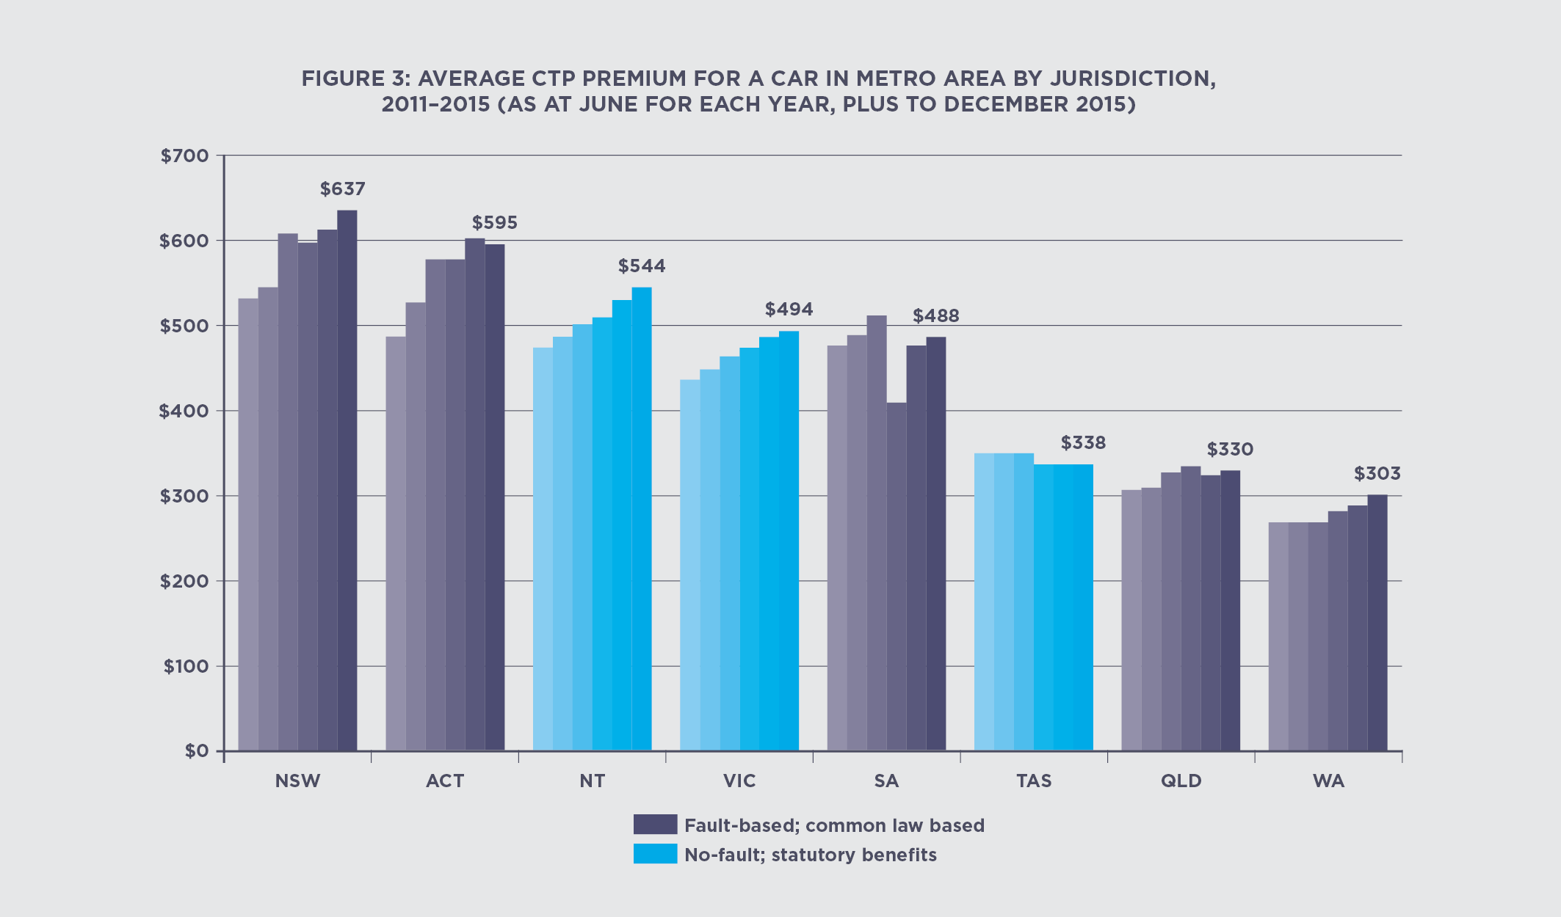
Sydney (metropolitan) passenger vehicle owners are now paying the highest premiums in the country with current prices ranging from $537 to $886 at an average of $637 as shown in Figure 3.
The table below shows the increase in the best price available to a Sydney passenger vehicle owner between 1 February 2015 and 1 February 2016.
 | Best Price | Best Price
Insurer | 1 Feb 2015 | 1 Feb 2016 | $ change | % change
AAMI | $505 | $572 | $67 | 13%
Allianz | $539 | $589 | $50 | 9%
CIC Allianz | $546 | $596 | $50 | 9%
GIO | $509 | $555 | $46 | 9%
NRMA | $545 | $588 | $44 | 8%
QBE | $500 | $537 | $37 | 7%
Zurich | $548 | $597 | $49 | 9%

How is the current CTP scheme performing against these objectives?
Figure 4 shows the average CTP price for a passenger vehicle in the metropolitan area since 2008.
There are a number of reasons why Green Slip prices have increased substantially since 2008.
The cost of a Green Slip is partly influenced by the benefits provided. Under the current NSW scheme, the benefits available, plus caps and thresholds where they exist, are considerably higher than in most other Australian jurisdictions as shown in the Appendix, however the amount actually received by claimants is often reduced by legal fees. There is an important question about whether the community is happy to bear higher prices, if that means higher benefits.
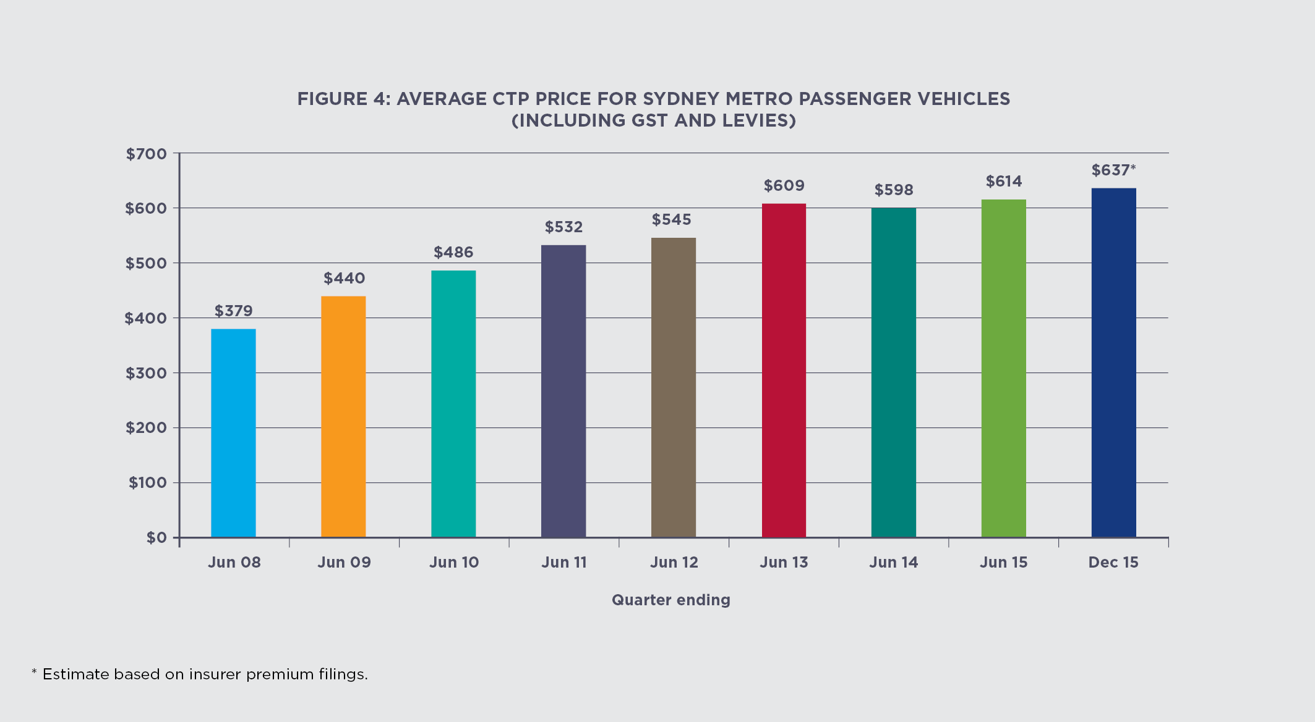
Green Slip price increases have also been driven by increasing claim numbers since 2008; especially claims by people who have minor injuries and are legally
represented. The number of legally represented claims for minor injuries has increased by 111% between 2008 and 2015, and 24% in just the past year (June 2014 to June 2015), while claims for more serious injuries have been steady.
Figure 5 (over the page) prepared by the scheme actuary Ernst & Young, shows the growth in legally represented claims for minor injuries. The sharp increase in the number of these claims is a significant contributor to the recent and predicted price increases.

How is the current CTP scheme performing against these objectives?
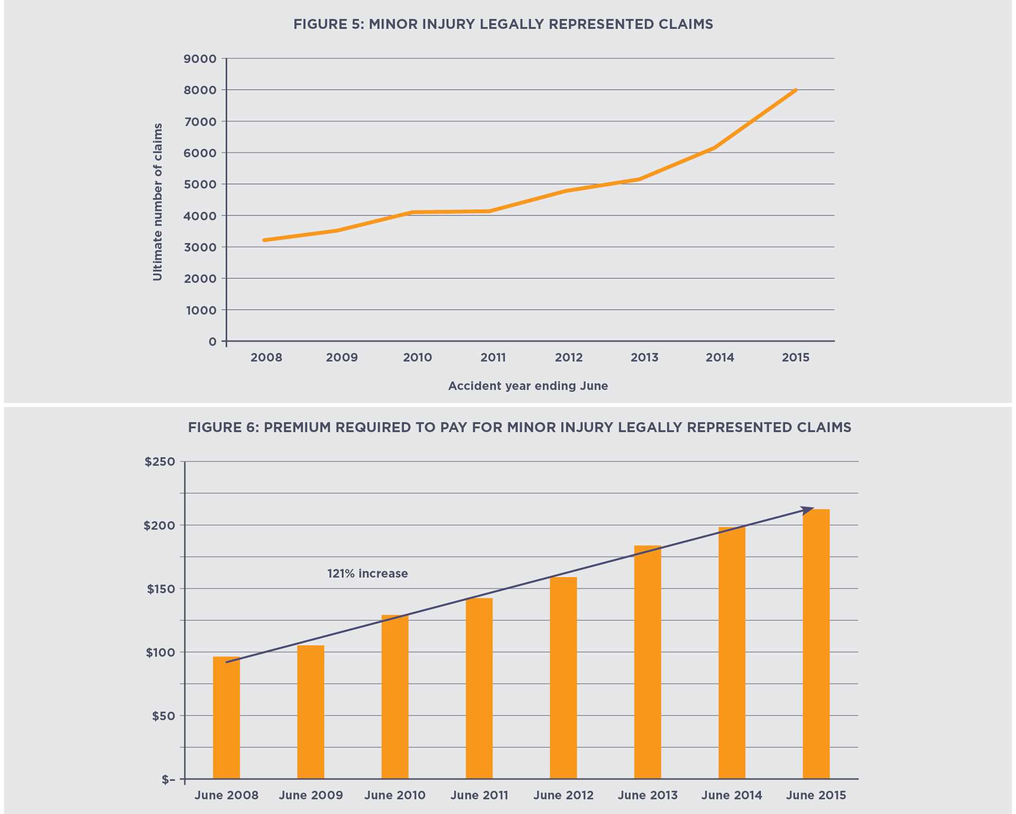
Minor injury claims of this type average between $95,000 and $110,000 each. As a result, around $213 of every Green Slip premium is going towards these claims, up from $96 in 2008, an increase of 121%, as shown in Figure 6.
Increasingly, claims include payment for care and domestic assistance, including assistance that may have been provided by family members. The cost of care has increased at very high rates since 2000 relative to other payment types and is also putting increasing pressure on Green Slip prices.
According to the scheme actuary, care costs per policy have increased steadily over the past 10 years, rising from $18 per policy in 2004 to $42 per policy in 2014. The rise in care costs has been most notable in claims from injured people who have minor injuries and are legally represented.
Common law schemes can become expensive because settlements are negotiated on a case by case basis. This can result in scheme costs increasing over time at a rate faster than normal inflation (called “Superimposed Inflation”). They are also more expensive to run, as the adversarial system is costly. Premiums in common law systems can be more volatile, as insurers need to predict how much they will be paying in lump sums several years into the future. This uncertainty is built into the premium by the conservative pricing of insurers, which has historically led to insurers obtaining larger than expected profit margins.
An independent review of insurer profit and competition was undertaken in 2015 and the recommendations from that review will be considered in this review. More commentary on the review of profit and competition is on page 13.
Some policy issues
Having analysed the current scheme performance against the Government’s review objectives, below are some of the other specific policy issues that need to be considered in light of potential reform options.

Fault versus no-fault
There is significant debate around whether a no-fault or at-fault scheme presents the best way of supporting or compensating injured road users, particularly whether all people should be covered or whether fault is the best way to ration and allocate the resources of the scheme.
Proponents of fault-based schemes (such as the one operating in NSW) believe that they:
- provide an incentive for people to drive safely
- provide greater flexibility to deal with individual and unique claims
- are more adaptable to changing legal and compensation environments
- are fair as someone who injures another person is responsible
- may allow for an injured person to negotiate for greater benefits.
Proponents of no-fault schemes (such as those operating in Victoria and New Zealand) believe that they:
- provide simpler, faster and more predictable paths for compensation
- do not unduly punish an injured driver for a momentary lapse in judgement
- provide benefits which are not reliant on the quality of representation and argument
- provide a fairer proportion of scheme funds going to the injured
- improve health outcomes, as needing to prove fault delays treatment and compensation.

Coverage for other injured road users
Many people injured on the NSW roads do not have access to CTP insurance. These include not only ‘at-fault’ drivers, but also road users injured by non-motorised vehicles (e.g. bicycles, skateboards) and motorised vehicles falling outside the registration and insurance system (e.g. dirt or off-road bikes, Segways). There are often practical and other considerations in bringing such vehicles into the formal registration and insurance systems, but there remains a gap in coverage for those injured.
Following the recent work of a Bicycle Compensation Working Party chaired by SIRA, and irrespective of the preferred benefit model, the Government is giving consideration to building a ‘safety net’ which would mean that people injured by such vehicles would have recourse to the Nominal Defendant in instances where the party at-fault had no insurance. A penalty (excess) would apply to anyone causing an injury in the event that person does not have some form of existing insurance. This would have the effect of adding some extra cost to CTP insurance, but it would allow for wider coverage.

First party versus third party scheme
At present, a not at-fault claimant needs to claim against the vehicle at fault. This means identifying the vehicle at fault, finding the insurer and then dealing with an insurer who may not be motivated to look after the claimant as they would their own customer. In the current system the insurer is actually representing the at-fault driver, not the claimant. As the injured person is generally not the insurer’s customer, there is little incentive for the insurer to perform well on claims and resolve them in the interests of the claimant.

Some policy issues
Allowing injured people to claim against their own insurer, just like comprehensive motor insurance, may change the way insurers view claimants. Only in cases where someone is injured outside of a vehicle, such as a pedestrian or cyclist, would they need to claim against the at-fault vehicle. This option becomes possible in a no-fault, defined benefits system, although there are certainly advantages in maintaining a single insurer which manages all claims arising from one accident.

Profit and competition
In December 2015, Zurich announced that from 1 March 2016 it would cease selling CTP policies in NSW. This reduces the number of licenced CTP insurers from seven to six (two insurance companies have multiple licences, so effectively there are now four CTP insurers in NSW).
A recommendation of the NSW Parliament Standing Committee on Law and Justice twelfth review of the functions of the (former) Motor Accidents Authority was that there should be a review of insurer profit and market competition in the CTP scheme. This was partly in response to concerns raised by stakeholders regarding the excessive insurer profits arising from the NSW CTP scheme.
CTP insurers are required to ‘file’ their proposed prices with SIRA and show that they fully cover anticipated liabilities and expenses, but are not excessive. In the filing, insurers must estimate their future costs for claims and other expenses including profit. This is known as the ‘filed’ or prospective view of profit.
Over the life of the scheme there has been a consistent pattern of discrepancy between ‘filed’ and realised profits of the CTP insurers. The long term average of realised profit is around 19%, which is more than double what insurers file for when setting their prices.
In late 2015 an independent review of insurer profit and competition was undertaken and the recommendations from that review will provide context and input to this review to help strengthen the regulatory framework, improve transparency and market competition. The Report of the Independent Review of Insurer Profit within the NSW Compulsory Third Party Scheme has been released in conjunction with this paper and is available at www.sira.nsw.gov.au.
The review makes constructive recommendations on mechanisms that can be put in place to better manage risks, potentially limit future premium growth and remove barriers to competition. These include approaches to assessing and applying risk rating factors, relaxing or removing some regulations or restrictions on aspects of insurer price setting, and reviewing the role of the regulator in price setting. While action has commenced on addressing the regulatory and administrative recommendations, the Government will consider the recommendations requiring legislative amendment as part of its wider review of scheme design.

Underwriting considerations
Some people argue that common law systems operate better in privately underwritten schemes. Because private insurers and injured claimants are each trying to maximise their position, they will eventually negotiate to a final lump sum. The insurer is able to extinguish their liability upon settlement. With the shift to private underwriting in South Australia in 2016, this will leave Western Australia as the sole publicly underwritten State still using common law for CTP.
A defined benefits, no-fault scheme is typically delivered by publicly underwritten monopoly providers in Australia and New Zealand, though there are a few exceptions overseas. The primary concern is that private capital does not work well in schemes in which some injured people may need benefits for the rest of their life. This is a reason why the public sector underwrites the LTCS scheme. Arguably, however, private insurers are well placed to deal with the large volume of smaller claims and can effectively manage such a system if there is a mechanism to commute claims.
It is also likely that some vehicle types (e.g. motorcycles) would see their premiums rise in the absence of certain controls in a no-fault scheme. Cross-subsidisation is easier to manage in a monopoly system, so a competitive system would need controls put in place to ensure affordability.
Some policy issues
In order to better deliver affordability if competitive underwriting is retained, the Government is giving consideration to the development of a risk pooling arrangement as an alternative to the current premium system. Risk pooling involves insurers coming together to form a pool so as to provide protection to insurers against catastrophic risk. This would apply in either a no-fault or fault-based system, though it would be imperative in a no-fault scheme to ensure that some prices did not escalate excessively. Risk pooling was an explicit recommendation of the independent review of insurer profit and competition. The current competitive system does not easily permit the transfer of cross subsidies from one risk to another. However, risk pooling may reduce the incentive on private insurers to price keenly, and can be seen as rewarding the less efficient insurer.

Wrong doing
A feature of most fault-based compensation schemes is the concept of contributory negligence, which in the current CTP scheme is a reduction in any entitlements as a result of the injured person doing, or not doing, something that subsequently contributes to their injuries (even though they did not cause the accident as such). Examples include a passenger in a car not wearing a seatbelt or a pedestrian who crosses the road against the lights or away from a nearby crossing.
In the current CTP scheme the award of damages is reduced by the same percentage as the claimant’s negligence. Deciding the degree of negligence can be subjective and is settled by agreement between the insurer and claimant or by SIRA’s dispute resolution service or the court.
Some will argue it is a fair outcome that contributory negligence is applied, while others will argue that since it was not the injured passenger or pedestrian who caused the accident they should not be penalised. There are different approaches to when and how contributory negligence is applied in no-fault schemes in other jurisdictions, specifically in terms of which benefits are reduced, or the way contributory negligence is calculated.
In fault-based schemes, the driver at fault is excluded from benefits and must rely on other support systems. This is seen by some as a just way of penalising them for their wrong-doing. However, it excludes people who have a momentary lapse or were injured after hitting an animal, which could leave them destitute.
In most no-fault schemes, however, access to benefits is not permitted where people are injured by their own serious wrong doing i.e. serious cases of negligence, criminal activity, intoxication or self-harm. In the Victorian no-fault scheme drivers convicted of dangerous driving causing death or serious injury are not entitled to compensation. However, if they are seriously injured, they are eligible for medical treatment and related care services. Those convicted of driving under the influence of alcohol or drugs, driving without a licence, stealing the vehicle or using it to escape are not eligible for income replacement.

Adequacy and consistency of lump sum payments
Common law systems typically pay once-only lump sums. Some people argue that lump sums create incentives to exaggerate claims to maximise payments (and for insurers to negotiate equally hard to keep payments down). They also argue that the payment of a lump sum also means that, for the injured person, no further support from the insurer will be provided after that time, including in particular, further assistance in the event that injuries subsequently deteriorate.
Recipients of lump sums also need to manage the lump sum for the rest of their life to ensure they have ongoing access to support. This means they are exposed to fluctuations in economic markets, which may see the value of their investments fall. Recipients of lump sums also need to avoid the temptation to use the lump sum for purposes unrelated to their injury. When the lump sum runs out, the injured person may be left to fend for themselves, or end up back on publicly funded support, eroding the purpose of insurance.
Some policy issues
Another aspect is the wide variation in lump sum settlements. Injuries, even when distinctly similar in nature, often attract disparate amounts of compensation. For example, compensation for minor injuries such as low level whiplash, sprain or moderate bruising can range from $10,000 to $120,000.
However, lump sum settlements have the benefit of allowing the recipient to make their own choices about how they support themselves into the future, while the insurer in turn is removed from ongoing liability for payments. It also permits negotiation for a settlement that is more closely linked to the needs of the individual, rather than relying on a pre-determined funding formula, and ongoing dependence on the insurance system.

Abuse of the system
Compensation systems can encourage people to abuse the system. This can include ‘soft fraud’ such as the embellishment or exaggeration of injuries by claimants (and occasionally ‘hard fraud’ such as a staged or fictitious crash) as the benefits paid often depend upon an assessment of the severity of the injury. This can be hard to prove or disprove. The common law lump sum scheme design may also encourage unacceptable behaviours by service providers, who may assist these claimants to build a case. A different scheme design may reduce or remove the opportunity or incentives to abuse the system which will ultimately result in reduced Green Slip costs for vehicle owners.

Questions on policy considerations
- Should there be support or a safety net for anyone injured on the roads by vehicles that are not part of the insurance system (like bicycles) even if that increases the overall cost of CTP?
- Is it better to make a claim against your own insurer as opposed to the insurer of the at-fault driver? If so, why?
- Should Government retain competitive private underwriting, or give consideration to a return to public underwriting delivery?
- How should Government best deal with fault (including injuries without another party to sue), illegal acts and contributory negligence in any reform?
- What changes to the CTP scheme could increase competition?

Potential reform options
The options that we are seeking comment on are based on schemes that are fault-based (lump sum, common law) or no-fault (defined benefits, paid periodically). As the current NSW system is fault-based, the options begin with incremental improvements to the current system, and move towards a more defined-benefits, no fault system.
The options presented below are not exhaustive and there are variations within each option. Comment is sought on the overall merits of the options, as well as any other issues that need consideration.

Potential  Reform Options | Option 1 –  Retain the current common law, fault-based scheme with process improvements (no change in benefits) | Option 2 –  Retain the current common law, fault-based scheme with adjustments to benefit levels as well as process improvements | Option 3 –  Move to a hybrid no-fault, defined benefits scheme with common law benefits retained in parallel | Option 4 –  Move to a fully no-fault, defined benefits scheme with caps, thresholds and no common law
Scheme type | Primarily fault-based, common law, lump sum settlements. | Primarily fault-based, common law, lump sum settlements. | No-fault, defined benefits, lump sum for the most seriously injured. | No-fault, defined benefits, no common law.
Defining features | This option proposes retaining the current primarily fault-based, common law CTP scheme with process improvements such as changes to dispute services, premium system and insurer regulation. | This option proposes retaining the current primarily fault-based, common law CTP scheme with process improvements as per Option 1 and revised caps and benefits. | This option proposes introducing defined statutory benefits for anyone injured in a motor vehicle accident, regardless of fault, with the retention of common law benefits for the most seriously injured. | This option proposes introducing a fully no-fault scheme which would provide defined, statutory benefits for anyone injured in a motor vehicle accident, regardless of fault, with no access to common law.
Where else this scheme operates | NSW  ACT | Queensland  South Australia  Western Australia | Victoria  Tasmania | New Zealand  Northern Territory

Potential reform options

Option 1 – Retain the current common law, fault-based scheme with process improvements
This option would involve retaining the current benefit structure but introducing improvements to processes especially where there is currently a high level of dispute. For example:
- mandatory assessment processes after a certain time period rather than allowing claims to remain open indefinitely
- internal review processes and compulsory mediation in claims prior to legal assessment
- lost earnings payments being available periodically rather than waiting for settlement for payment

How does this option address the objectives?
Proportion of benefits (efficiency) | This option would slightly improve efficiency.
Timeliness | Changes to claims and dispute resolution processes may slightly improve timeliness for some claims but many will see no impact.
Fraud and exaggeration | There would be tighter provisions dealing with fraud and exaggerated claims.
Affordability | There may be a marginal improvement in affordability as a result of some claims being resolved more quickly and tighter caps on legal costs.

- new powers for the regulator to address over-servicing and fraud
- greater support for claimants provided by SIRA and augmented by better information
- tighter caps on legal expenses
- clearer rules around the acceptance of liability and regulated rules around contributory negligence
- clearer rules around late claims
- new regulatory powers to address insurer premiums and profit.

Potential reform options

Option 2 – Retain the current common law, fault-based scheme with adjustments to benefit levels as well as process improvements
This option will include all the procedural improvements of Option 1 but will make adjustments to benefits levels. The benefit levels available under the current NSW CTP scheme are considerably higher than a number of Australian States and Territories as indicated in the Appendix table. This option would make adjustments to current benefit levels under the scheme by making any one or combination of the following reform options:

Adjustments to payments for non-economic loss
Under the current CTP scheme, damages for non-economic loss or ‘pain and suffering’ are only available if the degree of permanent impairment of the injured person as a result the motor vehicle accident is greater than 10%. Where a dispute arises between an insurer and injured person as to the degree of permanent impairment, either party may refer the matter to SIRA’s Medical Assessment Service for independent assessment. A court cannot award damages for non-economic loss unless the parties agree that the impairment exceeds 10% or a medical assessor has certified this.
The monetary amount for non-economic loss is capped and indexed annually. Currently, the maximum amount that may be awarded for non-economic loss is $511,000, provided the level of whole person impairment (WPI) exceeds 10%. If that threshold is exceeded, it is up to the parties to negotiate the compensation up to the cap. This can mean that the negotiating ability of the claimant can affect the payment outcome, which is a further example of how the current scheme generates uncertainty.
Consideration could be given to a lower overall cap or a graduated system linked to overall impairment, as is the case in other schemes, to provide greater certainty and fewer disputes, though the trade-off would be less flexibility to cater for individual circumstances.

Adjustments to payments for economic loss
The current CTP scheme reimburses injured people for loss of income caused by the injury. Compensation amounts are based on actual past loss of earnings and an estimate of future loss of earnings, but capped at $4,688 (after tax) per week, which is indexed annually. This is much higher than in other states for their common law claims. The NSW cap is more than five times the Average Weekly Earnings (AWE) compared to other States that cap common law economic loss payments at three times AWE. Tighter caps could be offset by new provisions that would aim to allow economic loss payments to be made progressively, rather than at final settlement.

Adjustments to payment for care
Currently, injured people can claim for the cost of care (i.e. attendant care and personal care), including care that may have been provided free of charge by family and friends, if such care exceeds a statutory threshold. An injured person must be able to show that the assistance is needed for at least six hours per week and for at least six consecutive months of the year. The injured person must also show that the same kind of service was not needed prior to the injury.
The cost of care has increased at very high rates since 2000 relative to other payment types. According to the scheme actuary, care costs per policy have increased steadily over the past 10 years, rising from $18 per policy in 2004 to $42 per policy in 2014. The rise in care costs has been most notable in claims from injured people who have minor injuries and are legally represented.
Limits on the type of care could be considered including consideration of the removal of access to funding for gratuitous care, as is the case in other jurisdictions.

Adjustments to legal fees
The complex process of negotiating claims and managing disputes in the current CTP scheme has led to increasing levels of legal representation and further cost. Today, 83% of claims have legal representation compared to 71% in 2008, and legal costs now exceed medical costs in the scheme.

Potential reform options
On 1 April 2015, the Government introduced regulatory changes which now require lawyers to disclose to SIRA details about their fees and the final settlement received by the claimant after all expenses have been paid. When these fees are taken into account, which do vary from claim to claim, the amount received in the hand by claimants is on average about 45 cents in the dollar of the CTP premium.
Consideration could be given to minimum thresholds before legal expenses may be made, and to link the value of payments to legal advisors based on the work performed, rather than the dollar value of the claim.

Medical excess
Under the current CTP scheme, an insurer who has admitted liability for a claim is required to reimburse an injured person for their reasonable and necessary medical, treatment and rehabilitation expenses. The maximum amount that an insurer is required to reimburse an injured person for the cost of medical services is the amount listed in the Australian Medical Association’s List of Medical Services (AMA List). The list sets out the fees which the AMA considers are “fair and reasonable and appropriate for medical practitioners to charge in relation to a range of services”.
An option is to consider an excess of medical payments similar to general home insurance i.e. an injured person would be required to pay a standard excess amount before being eligible to claim these benefits under the scheme

How does this option address the objectives?
Proportion of benefits (efficiency) | This option would slightly improve efficiency, depending on the limits imposed by any thresholds and caps.
Timeliness | Changes to claims and dispute resolution processes may slightly improve timeliness for some claims but many will see no impact.
Fraud and exaggeration | There would be tighter provisions dealing with fraud and exaggerated claims.
Affordability | There would be a slight improvement to affordability as benefits are amended, some claims are resolved more quickly and tighter caps on legal costs are introduced. The level of improvement would be dependent on the level of the thresholds and caps.

Option 3 – Move to a hybrid no-fault, defined benefits scheme with common law benefits retained in parallel
This option involves the introduction of defined statutory benefits for anyone injured in a motor vehicle accident, irrespective of fault, with the retention of common law benefits for the most seriously injured, as defined by injury type or a threshold. The nature, amount and duration of the defined benefits would be set by law, as opposed to the common law benefits which are negotiated between the claimant and insurer, within overall caps set by legislation.
It should be noted that different jurisdictions use different hybrid approaches, including percentage of worst case, points scale, percentage of Whole Person Impairment (WPI) or narrative test to determine eligibility for common law or access to payments for pain and suffering. A particular decision would be whether access to common law is an alternative to defined benefits or an add-on to defined benefits.
For those more seriously injured who were not at fault, the underlying scheme design would be unchanged – that is, common law rights would be retained, allowing future losses to be calculated according to common law principles and settled in a lump sum.

Potential reform options
The quantum of compensation between defined benefits and lump sum schemes cannot easily be compared. Under a defined benefits scheme, compensation is more closely linked to the medical and rehabilitation needs of the injured road user. Some minor injury claimants may receive a lower overall quantum of compensation than in a lump sum scheme, but are likely to gain access to payments much sooner.
Depending on the nature of any design, this option would refocus the efforts of lawyers from minor injury claims where compensation entitlements are more straightforward, to the more serious injuries where needs are more complex and uncertain. It would improve certainty on payments for CTP insurers, thereby reducing the uncertainty factor that is currently built into CTP prices.
There are a range of blended or hybrid schemes in other jurisdictions that take on some features of fault and no-fault. These schemes allow the injured person to receive both no-fault and fault benefits. In Victoria, for example, all people injured in motor vehicle accidents receive no-fault benefits however those seriously injured through another driver’s fault may receive a lump sum payment and make a common law claim.
Some possible variations within this option could include:
- payment of medical, treatment and rehabilitation costs to anyone irrespective of fault, but continue to maintain fault as a relevant consideration for other benefits such as lost income or pain and suffering
- increase the threshold of the current no-fault Accident Notification Form to a higher level (possibly with defined benefits and/or maximum time thresholds), but retain common law for all claims above that level
- introduce benefits on a no-fault basis for anyone catastrophically injured that are not already covered by the Lifetime Care and Support Scheme (i.e. economic and non-economic loss) but retain common law for less severe injuries.
The aim of this option would be to ensure that injured people receive immediate and ongoing benefits in accordance with need. The majority of claims that involve relatively minor injuries would be settled without the need to negotiate a settlement amount or with a more straightforward mechanism.

How does this option address the objectives?
Proportion of benefits (efficiency) | This option has potential significant efficiency improvements. The level of improvement would be determined by the thresholds and caps adopted.
Timeliness | The introduction of defined benefits with changes to claims and dispute resolution processes would significantly improve timeliness. There would remain some delays for people eligible for common law.
Fraud and exaggeration | Defined benefits would largely reduce the incentive and opportunity for fraudulent behaviours and significantly improve the integrity of the scheme, especially by removing incentives for low severity claims. Measures to address fraud would still be required.
Affordability | The certainty for insurers of defined benefits and the reduction in time for payments to be made combined with changes to benefits and scheme costs would improve affordability. The level of improvement would be dependent on the level of the benefits, thresholds and caps.

Potential reform options

Option 4 – Move to a fully no-fault, defined benefits scheme with caps, thresholds and no common law
This option would remove the assessment of fault in all cases and provide defined statutory payments instead of lump sum payments.
Option 4 would eliminate disputation over fault. Like option 3, it would aim to improve certainty and timeliness of payments to injured people, and increase certainty for insurers in their pricing. However, like option 3, it could also reduce compensation for more minor injuries (and associated legal fees). Unlike option 3, there would be no negotiated lump sum.
Although no-fault schemes mean that a greater number of people are eligible to access benefits, they are not necessarily more expensive than fault-based schemes. To the contrary, the extension of benefits is usually offset by a reduction in technical legal disputes over fault, liability and contributory negligence. Costs are also contained by the caps placed on the defined benefits.
Premiums in no-fault systems are usually more stable because costs are more predictable and insurers do not need to make allowance for superimposed inflation. In a defined benefits system, there is greater certainty
and accordingly less need for insurers to include buffers in premiums in order to account for uncertainty in future claims liabilities and disputation costs. Insurers are better able to predict their likely future costs, resulting in more accurate pricing and less volatility of profits.
There are also fewer disputes under a statutorily defined benefits scheme, due to increased certainty about the benefits that are payable. A disadvantage of statutorily defined benefits, however, is that since benefits are pre-determined, the system is less flexible and lacks the ability to take all the circumstances of an individual case into account. Statutory defined benefits schemes make assumptions as to loss of income but may fail to take into account the unique impacts on an individual’s income that may be associated with different injury types.
The development of a National Injury Insurance Scheme also shows that the national trend is towards no-fault type schemes. In 2011, the Productivity Commission concluded that no-fault schemes are superior to fault-based schemes: “Overall, no-fault systems are likely to produce generally superior outcomes compared with fault-based systems. This assessment is consistent with the findings and recommendations of past official inquiries and reports that have investigated the matter”.

How does this option address the objectives?
Proportion of benefits (efficiency) | This option would result in a significant improvement in efficiency but may impact benefits for the most severely injured.
Timeliness | The introduction of defined benefits with changes to claims and dispute resolution processes would significantly improve timeliness.
Fraud and exaggeration | Defined benefits would reduce the incentive and opportunity for fraudulent behaviours and improve the integrity of the scheme. Measures to address fraud would still be required.
Affordability | The certainty for insurers of defined benefits and the reduction in time for payments to be made, combined with changes to benefits and scheme costs would improve affordability. The level of improvement would be dependent on the level of the benefits, thresholds and caps.

Potential reform options

Questions on possible options
- What should be the most important features in any scheme reform?
- On balance, which option or combination of options do you believe best addresses the priorities for improving the scheme and why?
- Does fault in an accident remain the most acceptable way of determining eligibility for benefits or is it more important that anyone injured on the road is covered, even if this means fewer savings in any reform?
- Is it more important to reduce CTP prices or to extend benefits to more people?
- Are people better looked after if receiving a negotiated lump sum (often years) after the accident or receiving prescribed weekly benefits shortly after making their claim?
- Should a greater proportion of funds go to the more severely injured, even if this means capping benefits or introducing an excess for low severity injuries?
- If Government retains common law, should there be tighter restrictions and caps on various benefits as is the case in other States, or if the Government adopted defined benefits should the caps and thresholds reflect what is paid in other States?
- If the Government retains common law, what is the best method and threshold to determine eligibility?
- If Government retains common law, what mechanisms should be adopted to resolve claims more quickly and avoid lengthy negotiations and disputes?
- Should there be limits to legal expenses, especially for small claims, and should legal expenses be linked to the work performed or the value of the claim?

How to make a submission
Comments can be sent to: CTP_Review@sira.nsw.gov.au or
by post (marked confidential) to:
CTP Review
State Insurance Regulatory Authority
Level 25
580 George Street
Sydney NSW 2000
by Friday 22 April 2016.
Please indicate which question(s) you are responding to or you can use the PDF submission form.
The CTP Options Paper and PDF submission form are available from
www.sira.nsw.gov.au/CTP-reforms
Please note that the Government has not yet made any decisions. All comments will be considered before the Government makes any decisions about whether changes will be made to the CTP scheme.
The Government reserves the right to publish submissions and authors should indicate if any or all of a submission should not be made public.

Glossary
Accident Notification Forms (ANFs) | The form provides for the early payment of reasonable and necessary medical expenses and/or lost earnings up to a maximum of $5,000. ANFs can be lodged by at-fault and not at-fault injured parties.
Affordability | Average premium (including levies but excluding GST) charged in the quarter divided by average weekly earnings in the quarter. The higher this ratio the less affordable the premium.
Claim frequency | Ultimate number of claims divided by the number of vehicles.
Claims handling expenses | Refers to expenses related to managing and administering CTP claims. These expenses include costs of claims staff managing claims, rehabilitation staff, managers and support staff.
Claims | The claims in the NSW CTP scheme are split into full claims, ANFs and workers compensation recovery claims.
Cost per policy | Total cost of claims divided by the number of insured motor vehicles in NSW.
Gratuitous care | Refers to services which are provided to an accident victim without payment and include services of a domestic nature, services relating to nursing and services that aim to alleviate the consequences of an injury.
Green Slip | This is also known as a CTP policy. The term ‘Green Slip’ dates back to the start of the NSW CTP scheme in 1989 where the CTP insurance invoice was a detachable green coloured slip.
Narrative Test | Where the injury is considered to have resulted in less than 30% of WPI (whole person impairment) the medical practitioner should consider if the injury has resulted in any of the following consequences: serious long-term impairment or loss of a body function, permanent serious disfigurement, severe long-term mental or severe long-term behavioural disturbance or disorder, or the loss of a foetus.
Profit margin | Refers to the proportion of premium in excess of all insurer claims and expenses. Levies and GST are excluded from assessing the profit margin.
Scheme efficiency | The amount of each premium dollar, excluding GST and levies, that is returned to injured people.
Superimposed inflation | The increase in claim costs over time, over and above wage inflation.
Underwriting year | The year the CTP policy was effective from.
Whole person impairment | Permanent impairment of any body part, system or function to the extent to which it permanently impairs an individual as a whole person.
Appendix: Comparison of schemes around Australia
 | NSW | VIC | TAS | QLD | SA | WA | ACT | NT
Scheme type | Primarily fault-based, common law with restrictions | Hybrid – no-fault defined benefits, common law with restrictions for the most seriously injured | Hybrid – no-fault defined benefits, common law with restrictions | Fault-based, common law with restrictions | Primarily fault-based, common law with restrictions | Fault-based, common law with restrictions | Fault-based, unrestricted common law | No-fault, defined benefits only
Average premium - December 2015 | $637 | $494 | $338 | $330 | $488 | $303 | $595 | $544
Underwriting model | Private insurers | Public monopoly | Public monopoly | Private insurers | Public monopoly – private insurers from 1/7/16 | Public monopoly | Private insurers | Public monopoly
Benefit Mechanism | Lump sum payments | Defined benefits | Defined benefits | Lump sum payments | Lump sum payments | Lump sum payments | Lump sum payments | Defined benefits
Common law (court) access | Yes | Yes – serious injury only | Yes | Yes | Yes | Yes | Yes | No
Are no-fault benefits available to the severely injured? | Yes – by Lifetime Care and Support Authority | Yes | Yes | Yes – from 1 July 2016 | Yes | Yes – from 1 July 2016 | Yes | Yes
Are no-fault medical and rehabilitation benefits available? | Limited – everyone can claim up to $5,000 within 6 months of accident under the Accident Notification Form (ANF) | Yes -reasonable cost of medical, treatment and rehab services once a medical excess of $623 reached | Yes – capped at $400,000 or unlimited if more than 2 hours a day care is required | N/A | Limited –medical and treatment costs for children under 16 provided irrespective of fault | Limited - emergency public hospital treatment and transport costs provided irrespective of fault | N/A | Yes – reasonable and necessary costs
Are no-fault income benefits available? | Limited - under the ANF, payment for lost earnings can be made after treatment expenses have been paid | Yes - 80% of earnings up to $1,250 per week, in the first 18 months after the accident. First 5 days not covered | Yes - 80% of earnings, up to 3 times average weekly earnings ($3,867.90 gross), for 2 years (usual work) or 5 years (any work). First 7 days not covered | N/A | N/A | N/A | N/A | Yes – 85% of Northern Territory average weekly earnings (currently $1,510.90 gross), up to 65 years

Appendix: Comparison of schemes around Australia
 | NSW | VIC | TAS | QLD | SA | WA | ACT | NT
Is past or future economic loss capped or restricted under common law? | Yes – capped at $4,688 per week net ($7,812 gross) may be paid indefinitely. | Yes – capped at $1,166,240 and not available if assessed at less than $51,800 | Yes – capped at 3 times average weekly earnings in Tasmania (currently $3,867.90 gross) | Yes – capped at 3 times average weekly earnings in Queensland (currently $4340.10 gross) | Yes – future economic loss available when an injury exceeds 7 points on the Injury Scale Values (ISV) scale | Yes – capped at 3 times average weekly earnings in WA (currently $5,076.90 gross) | No | N/A
Are no-fault lump sum impairment benefits available? | N/A | Yes - available if greater than 10% impairment, sliding scale from $7,310 to maximum of $333,630 | No | N/A | N/A | N/A | N/A | Yes - available if greater than 5% whole person impairment, capped at $294,770
Is domestic assistance capped or restricted? | Yes – only available if assistance is needed for at least 6 hours per week and for at least 6 consecutive months of the year | Gratuitous care is not recoverable | Yes - gratuitous care only available to the severely injured | Yes – only available if assistance is needed for at least 6 hours per week and for at least 6 consecutive months of the year | Yes – if injury exceeds 10 points on the Injury Scales Values (ISV) scale and the services are provided for 6 hours per week for at least 6 consecutive months | Yes – minimum threshold of $5,000 and cap on entitlement to an amount equivalent to average weekly earnings, maximum of 40 hours per week | No | Yes – for claims before 1 July 2014, maximum of 32 hours per week. For claims after 1 July 2014, benefits are payable for one year after the date of the motor accident
Are payments for non-economic loss (pain and suffering) restricted under common law? | Yes – only available if greater than 10% whole person impairment and capped at $511,000 | Yes – only available if assessed at more than $51,800 and capped at $518,300 | Yes – only available if assessed at or above $5,000 | Yes – capped at $350,000 | Yes – when an injury exceeds 10 points on the Injury Scale Values (ISV) scale. No cap | Yes – capped at $390,000 and not available if assessed at less than $19,500 | No | N/A
Are legal fees capped or restricted? | Yes – regulation sets maximum fees however lawyers can ‘contract out’ and charge more than the fixed costs | Court scale | Court scale | Yes – claimant’s legal fees not reimbursed if benefit to the claimant is less than $43,020 and limited to $3,600 if the benefit is between $43,020 and $71,730 | Court scale | Court scale | Yes – if claimant’s legal fees are less than $50,000, a lawyer is not entitled to be paid | N/A

Disclaimer  This publication may contain information that relates to the regulation of Compulsory Third Party insurance in NSW. It may include some of your obligations under the various legislations that the State Insurance Regulatory Authority (SIRA) administers. To ensure you comply with your legal obligations you must refer to the appropriate legislation. Information on the latest laws can be checked by visiting the NSW Legislation website legislation.nsw.gov.au.  This publication does not represent a comprehensive statement of the law as it applies to particular problems or to individuals or as a substitute for legal advice. You should seek independent legal advice if you need assistance on the application of the law to your situation. |  |  | This material may be displayed, printed and reproduced without amendment for personal, in-house or non-commercial use.  © State Insurance Regulatory Authority (SIRA)  Catalogue no. SIRA08055  State Insurance Regulatory Authority  Motor Accidents Insurance Regulation, Level 25,  580 George Street, Sydney NSW 2000  General phone enquiries 1300 137 131 or  Claims Advisory Service 1300 656 919  Website www.sira.nsw.gov.au  ISBN 978-1-74341-634-1 © Copyright State Insurance Regulatory Authority NSW 0316.

Assuming the Lifetime Care and Support levy was added to benefits paid to claimants in the above illustration, the proportion of the Green Slip dollar paid to injured people is around 50%. This cannot be adopted as a combined efficiency ratio for the CTP and Lifetime Care and Support schemes as they are fundamentally different in structure, cash flows and operation.
Includes money paid by a claimant from their settlement to their lawyer.
Motor Accidents Authority (now SIRA) survey of 660 claimants, June 2015
Insurancenews.com.au 4 June 2012
Best price is based on the lowest price offered for a new CTP policy for a driver under 55 years of age
This document has been prepared as a general guide to motor accidents compensations schemes in Australia and information may have updated. Please contact the individual schemes if you require further information or clarification of details.
Metropolitan passenger vehicle, including GST and levies.
As at 1 July 2014.

